**CORPORATE FINANCE**

Table of Contents

Reading 34: Corporate Governance and ESG: An Introduction 5

a. Describe corporate governance 5

b. Describe a company’s stakeholder groups and compare interest of stakeholder groups 5

c. Describe principal-agent and other relationships in corporate governance and the conflicts that may arise in these relationships 5

d. Describe stakeholder management 6

e. Describe mechanisms to manage stakeholder relationships and mitigate associated risks 6

f. Describe functions and responsibilities of a company’s board of directors and its committees 7

g. Describe market and non-market factors that can affect stakeholder relationships and corporate governance 8

h. Identify potential risks of poor corporate governance and stakeholder management and identify benefits from effective corporate governance and stakeholder management 9

i. Describe factors relevant to the analysis of corporate governance and stakeholder management. 9

j. Describe environmental and social considerations in investment analysis 10

k. Describe how environmental, social, and governance factors may be used in investment analysis 10

Reading 35: Capital Budgeting 12

a. Describe the capital budgeting process and distinguish among the various categories of capital projects 12

b. Describe the basic principles of capital budgeting 12

c. Explain how the evaluation and selection of capital projects is affected by mutually exclusive projects, project sequencing and capital rationing 13

d. Calculate and interpret net present value (NPV), internal rate of return (IRR), payback period, discounted payback period and profitability index (PI) of a single capital project 13

e. Explain the NPV profile, compare the NPV and IRR methods when evaluating independent and mutually exclusive projects and describe problems associated with each of the evaluation methods 15

f. Describe expected relations among an investment’s NPV, company value and share price 16

Reading 36: Cost of Capital 17

a. Calculate and interpret de weighted average cost of capital (WACC) of a company. 17

b. Describe how taxes affect the cost of capital from different capital sources 17

c. Describe the use of target capital structure in estimating WACC and how target capital structure weights may be determined 17

d. Explain how the marginal cost of capital and the investment opportunity schedule are used to determine the optimal capital budget 18

e. Explain the marginal cost of capital’s role in determining the net present value of a project 18

f. Calculate and interpret the cost of debt capital using the yield-to-maturity approach and the debt-rating approach 18

g. Calculate and interpret the cos of noncallable, nonconvertible preferred stock 18

h. Calculate and interpret the cost of equity capital using capital asset pricing model approach, the dividend discount model approach and the bond-yield-plus risk-premium approach 19

i. Calculate and interpret the beta and cost of capital for a project 20

j. Describe uses of country risk premiums in estimating the cost of equity 20

k. Describe the marginal cost of capital schedule, explain why it may be upward-sloping with respect to additional capital and calculate and interpret its break-points 21

l. Explain and demonstrate the correct treatment of flotation costs 22

Reading 37: Measures of Leverage 23

a. Define and explain leverage, business risk, sales risk, operating risk and financial risk and classify a risk 23

b. Calculate and interpret the degree of operating leverage, the degree of financial leverage and the degree of total leverage 23

c. Analyze the effect of financial leverage on a company’s net income and return on equity 24

d. Calculate the breakeven quantity of sales and determine the company’s net income at various sales levels 24

e. Calculate and interpret the operating breakeven quantity of sales 25

Reading 38: Working Capital Management 26

a. Describe primary and secondary sources of liquidity and factors that influence a company’s liquidity position 26

b. Compare a company’s liquidity measures with those of peer companies 26

c. Evaluate working capital effectiveness of a company based on its operating and cash conversion cycles and compare the company’s effectiveness with that of peer companies 27

d. Describe how different types of cash flows affect a company’s net daily cash position 28

e. Calculate and interpret comparable yields on various securities, compare portfolio returns against a standard benchmark, and evaluate a company’s short-term investment policy guidelines 28

f. Evaluate a company’s management of account receivable, inventory and accounts payable over time and compared to peer companies 29

g. Evaluate the choices of short-term funding available to a company and recommend a financing method 30

# Reading 34: Corporate Governance and ESG: An Introduction

## Describe corporate governance

Internal controls and procedures by which companies are managed. Defines rights, roles and responsibilities of groups in an organization. Defines checks, balances and incentives to minimize conflict of interests.

On the side of the shareholder theory, corporate governance looks for measures to increase the value of a firm and avoid conflict of interests between owners and managers.

Stakeholder theory takes into account a broader sight. Considers conflicts among all of the groups that have interest on the company’s performance.

## Describe a company’s stakeholder groups and compare interest of stakeholder groups

* Shareholders: profitability, residual interest, growth, value.
* Board of directors: they protect interests of the shareholders. Set the management team, strategic directions, monitor financial performances.
* Senior managers: their interests are being employed and maximize the value of their compensation. This implies, an interest for the company’s performance.
* Employees: they look for higher pays, career opportunities, training and working conditions. Then, they must also look for the company’s performance.
* Creditors: they are also interested in the firm’s performance and in the covenants established in the debt agreements.
* Suppliers: they are interested in preserving their relationship with the company, profitability, growth, solvency and stability.

## Describe principal-agent and other relationships in corporate governance and the conflicts that may arise in these relationships

Principal-agent conflict

Happens due to the fact that generally the interests of the agent do not coincide with the ones of the principal. Standards, specific processes and compensations are measures taken to minimize this conflict.

Between shareholders and managers or directors

The principal-agent conflict can be clearly seen in this relationship. For instance, as shareholder have a diversified portfolio, they could ask managers to assume certain risk positions that considering their diversified portfolio could be minimal but, for the company by its own, it might be quite relevant. Information asymmetry may also generate a conflict since shareholders could not be given accurate or relevant information.

Between groups of shareholders

Groups may be created, leading to differentiation between leading groups and minority shareholders. This may lead to a certain set of decisions to benefit themselves to the detriment of the minority. Related party transactions are an example.

Between creditors and shareholders

Due to the limited upside results that creditors can face, they are less reliant to risky decisions than shareholders, who do not face this limitation.

Between shareholders and other stakeholders

Decisions that might affect costumers, government, employees…

## Describe stakeholder management

## Describe mechanisms to manage stakeholder relationships and mitigate associated risks

Stakeholder management refers to the management of relations, interests and communication with stakeholders. It is composed by:

* Legal infrastructure: identifies laws relevant to the stakeholders.
* Contractual infrastructure: looks at the contracts between the company and its stakeholders to identify rights and responsibilities.
* Organizational infrastructure: refers to corporate governance procedures that indicate how to manage stakeholder relationships.
* Governmental infrastructure: identifies regulations that may affect the company.

Annual general meeting: to communicate results to shareholders.

Proxy: when a shareholder assigns the right to vote to another who will attend the meeting. The proxy can either specify a voting posture or leave it to the discretion of the holder.

Ordinary resolutions: require a simple majority of votes (approval of auditor, election of directors…)

Special resolutions: may require a supermajority (mergers or acquisitions…).

Extraordinary general meetings: normally arise due to the need of voting a special resolution.

When there are multiple elections of board members, two voting methods may be used:

* Majority voting: the candidate with most votes for each single position is elected.
* Cumulative voting: shareholders can cast all their votes (shares * number of board position elections) for a single board candidate. This may end up with a greater minority shareholder representation.

## Describe functions and responsibilities of a company’s board of directors and its committees

**Board structure**:

One-tier board: a single board of directors that include internal (executive directors) and external (non-executive directors) directors. The non-executive directors can be independent directors, as they have no relationship with the company.

Two-tier board: there is a supervisory board that excludes executive directors. The one of directors is the management board and they operate independently.

Staggered board: a board where the seats are agreed and elected for certain periods.

**Board responsibilities**

By law, the board needs to act in the interests of the company’s shareholders

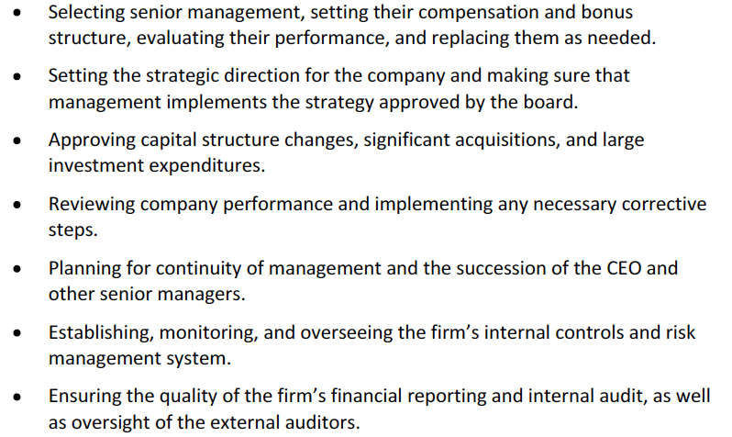

**Board committees**

Boards are frequently divided in different committees due to the expertise of its member (however, the responsibilities still fall in the board as a whole):

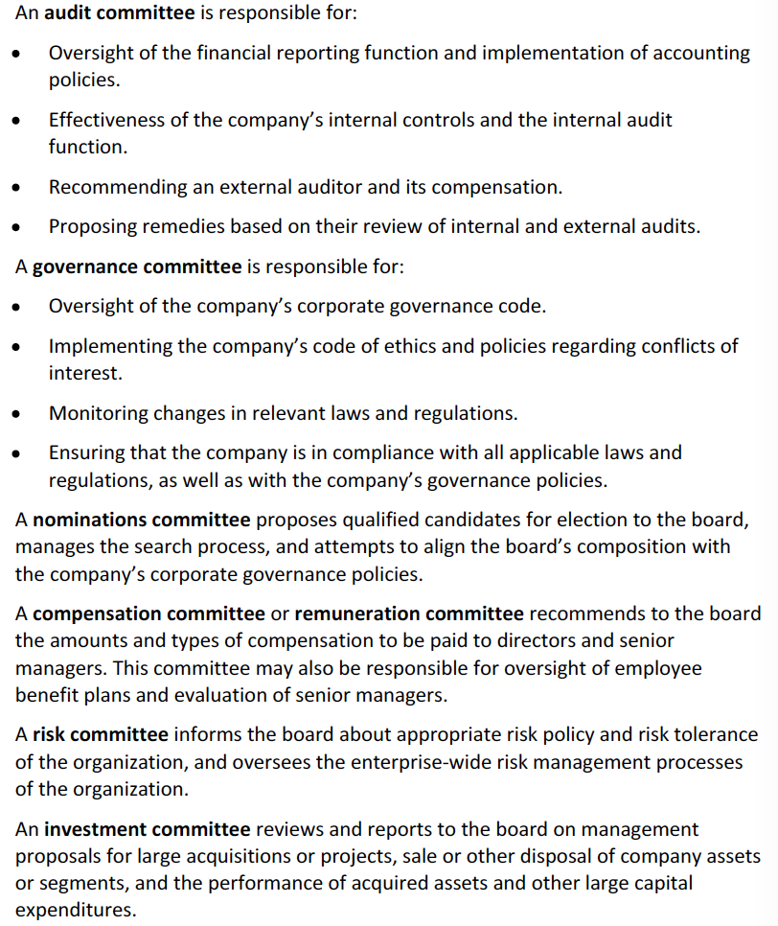

Although the size and number of committees that a board can have may vary depending of the company, regulators usually require companies to have an audit committee (and ra risk committee for the cases of financial institutions).

## Describe market and non-market factors that can affect stakeholder relationships and corporate governance

Activist shareholders: are the ones who pressure the company to pursue certain changes for their benefit.

Proxy fight: when shareholder look for the proxies of other shareholders to vote in favor of their proposals.

Tender offer: an offer to purchase some or all of the shares (when it is more than 5%, it should be disclosed).

Hostile takeover: happens when a group wants to make certain decisions not supported by management and the board and can be accomplished through a proxy fight or a tender offer.

Legal factors may also affect the relationships among stakeholders. For instance, interests of creditors and shareholders are believed to be better protected under a common-law system (judges’ ruling may become law) than in a civil law system.

Communication through medias (and the power that certain groups have over it) may also alter the relationships.

Funds are forced to use the proxies of their investors in the best interest of these investors.

## Identify potential risks of poor corporate governance and stakeholder management and identify benefits from effective corporate governance and stakeholder management

**Risks:**

* Poor record keeping.
* Fraud.
* Stakeholders taking decisions or acting to benefit themselves to the detriment of others.
* Principal-agent conflict.
* Conflict of interests.
* Legal and reputational risks.

**Benefits:**

* Improve operational efficiencies.
* Aligned interests among the company’s stakeholders.
* Control and monitoring.
* Avoid legal and regulatory risks.
* Help reduce financing costs, since it reduces default risk.
* An overall increase in the company’s value.

## Describe factors relevant to the analysis of corporate governance and stakeholder management.

Corporate governance has been considered as a relevant factor when analyzing a company’s performance. Some of the aspects that are looked at are:

* Company ownership and voting structure: use of different classes is frequently used to assure company ownership from the founder group (for instance, a class that holds more votes could imply that the holder group might have an economic ownership which does exceeds the 50% but, still, have control of the company). Companies with more than one class have usually traded at a discount to comparable companies. This helps the analyst to check the interest that may prevail in the board.
* Compositions of a company’s board: considerations are if directors are executive, non-executive or independent directors; are involved in related-party transactions; have diversity of appropriate expertise; have served maybe for too long to the board. What is important here is to determine if the board will correctly represent its shareholders’ interests.
* Management incentives and remuneration: check if the incentives lead the management team to pursue short or long term objectives; when performance incentives are stable, it suggests that objectives are easy to achieve; remuneration compared to industry peers; if incentives are aligned to current objectives.
* Composition of shareholders: check if there is a group that has a significant portion of the voting rights.
* Relative strength of shareholders’ rights: is basically to determine if the rights of shareholders are strong or not. Anti-takeover provisions, staggered boards and super voting share classes are example of cases that weakens the rights.
* Management of long-term risks: Stakeholder management.

## Describe environmental and social considerations in investment analysis

ESG (environmental, social and governance) investing (also referred to sustainable investing or responsible investing or even socially responsible investing): taking into account governance, social and environmental factors in the decision of investing.

It has been determined that using ESG factors when determining risk and expected return of security does not violate a manager’s fiduciary duties.

## Describe how environmental, social, and governance factors may be used in investment analysis

Approaches to integrate ESG factors to the portfolio management process:

* Negative screening: exclude companies and industries based on their practices regarding ESG factors.
* Positive screening: identify companies with positive ESG practices.
* Best-in-class approach: look among the industries for the company with best ESG practices.

ESG integration and incorporation refer to the integration of ESG factors when considering an investment opportunity.

Impact investing refers to investing in companies or projects to promote specific environment or social goals. Investors seek for profit + ES benefits.

Thematic investing refers to investing in an specific sector or industry that pursue a single goal.

# Reading 35: Capital Budgeting

## Describe the capital budgeting process and distinguish among the various categories of capital projects

Capital budgeting process refers to the identification and evaluation of capital projects (the ones that will generate cash to the firm in a period longer than a year). Capital budgeting decisions might be the most important ones due to their cost and the possible outcomes in terms of value.

Administrative steps in capital budgeting:

* Idea generation: is the most important step and can come from several sources.
* Analyzing project proposals: cash flow forecast to determine profitability.
* Create the firm-wide capital budget: take into account the company’s position, its resources and whether it make sense or not in terms of strategy (also consider other projects).
* Monitoring decisions and conducting a post-audit: compare actuals with projections, look for reasons, look for systematic errors in forecasts to improve estimates, how can the project and the company’s general operations can be improved.

Categories of capital budgeting projects:

* Replacement projects to maintain the business: Here the decision is simple, will the process continue, or changes are needed? Should operations continue?
* Replacement projects for cost reduction: A deep analysis to determine if the current equipment, although no obsolete, should be changed to reduce costs.
* Expansion projects: A broad analysis is needed including demand, cost, supply, management, among others, analysis.
* New product or market development: A lot of uncertainty is faced; therefore, a lot of analysis is needed.
* Mandatory projects: Usually demanded by regulator and authorities. Although it may not be expected to generate positive cash flows, it is important to check its costs and effects in the business.
* Other projects:

## Describe the basic principles of capital budgeting

Key principles:

* **Decisions are based in cash flows, not accounting income:**

Incremental cash flows are the ones which are taken into account, which refers to the changes in cash flow if the project is undertaken.

Sunk costs must not be taken into account.

Externalities refer to the effect of the project on other firm cash flows and should be taken into account (cannibalization). They can be positive or negative.

Conventional cash flow pattern happens when cash flows’ sign changes only once. Unconventional cashflows are the ones which sign can change twice or more.

* **Cash flows are based on opportunity costs:**

Refers to the cash flows that will be lost by undertaking a project.

* **The timing of cash flows is important.**
* **Cash flows are analyzed on an after-tax basis.**
* **Financing costs are reflected in the project’s required rate of return.**

So, this cost must not be considered when estimating cash flows.

## Explain how the evaluation and selection of capital projects is affected by mutually exclusive projects, project sequencing and capital rationing

**Independent and mutually exclusive projects:**

Independent: are unrelated, so the analysis can be made exclusively.

Mutually exclusive: when project compete with each other and only one can be undertaken.

**Project sequencing:**

When investing in a profitable project today, could create an investment opportunity in the future.

**Unlimited funds and capital rationing:**

Capital rationing appears when a company is limited by its capital availability. This must be taken into account when pursuing projects.

## Calculate and interpret net present value (NPV), internal rate of return (IRR), payback period, discounted payback period and profitability index (PI) of a single capital project

**Net present value**

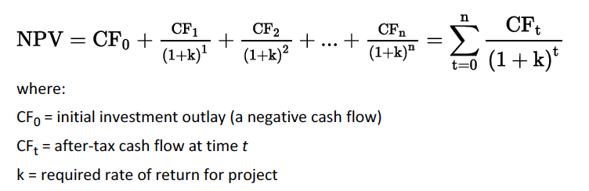

Positive NPV increases shareholders wealth and negative NPV decreases it.

**Internal rate of return**

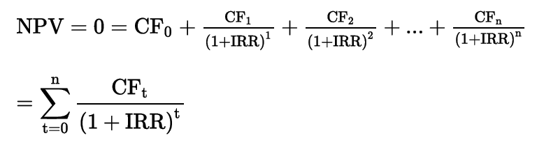

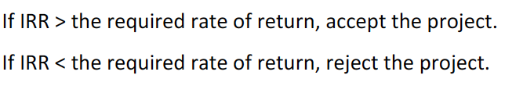

**Payback period**

It is simply the period of time that it takes to recover the initial investment.



It is not a measure of profitability. It is a measure of liquidity. They payback period and the discounted payback period may be calculated with the TI.

**Discounted payback period**

It is like the payback period but using the present values of the cash flows. It is important to mention that neither of these two measures considers the flows after the payback period is reached, which limits the use of the indicator as a profitability measure.

**Profitability index**

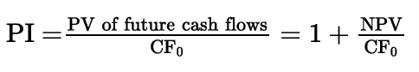

If it is greater than zero, accept. This index is likely to coincide with the NPV and IRR. The PI can be computed by simply adding CF0 to the NPV and dividing it by CF0.

## Explain the NPV profile, compare the NPV and IRR methods when evaluating independent and mutually exclusive projects and describe problems associated with each of the evaluation methods

NPV profile shows the NPV for different rates.

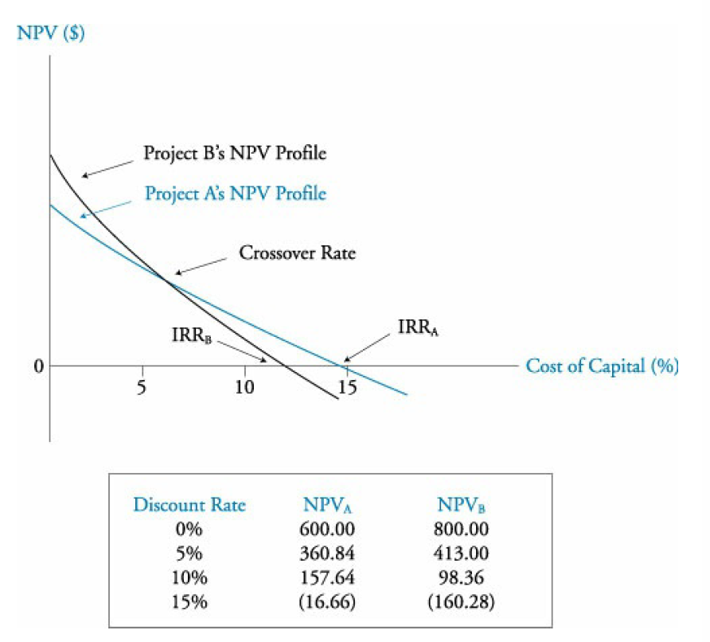

The IRR for the projects is the one that intersects with the x axis (where NPV = 0).

The crossover Rate is the discount rate at which both projects lead to the same NPV. In order to calculate the crossover rate, simply subtract the cash flows of both projects and calculate the IRR of the difference.

**Advantages and issues with the NPV and the IRR methods**

NPV is a direct measure of the increase in the value of the firm. The thing is that it does not considers the size of the project, as it does not take into account the relativity of outflows and inflows (is absolute).

The IRR measures profitability as a percentage of profit per dollar invested. The disadvantages are that the outcome when comparing mutually exclusive projects may differ to the one that appears when using the NPV method and that a project may have multiple IRR which is kind of misleading.

**Project ranking conflicts**

For the cases in which the IRR method has issues with the NPV method, the method to choose is the one of the NPV, as it shows which project will generate more value to the company. The conflict come from cash flow timing differences and the size of the project. As the IRR is a percentage, it is relative to size while the NPV is absolute.

The NPV method assumes that flows are reinvested at the discount rate, which make sense since it would be expected that flows can be reused for the company.

However, the IRR methods assumes that the reinvested rate is the IRR which is unrealistic.

**Multiple and no IRR problem**

Both of these issues may happen due to unconventional flows.

## Describe expected relations among an investment’s NPV, company value and share price

In theory, a positive NPV project should bring a proportional in the share price.

# Reading 36: Cost of Capital

## Calculate and interpret de weighted average cost of capital (WACC) of a company.

## Describe how taxes affect the cost of capital from different capital sources

Marginal cost of capital (MCC) = WACC

Capital components of a firm: Right side of the balance sheet. Each component has a specific cost.

Kd Debt rate.

Kd(1-t) After-tax cost of debt.

Kps Cost of preferred stocks.

Kce Cost of common equity.

The reason why an after-tax cost of debt is used is because the cash flows calculated when determining the value of a firm are also after-tax.

Value is created when the ROA > WACC (it can be also applied to a set of specific assets). In essence this is the main criteria when making capital budgeting.

It is important, however, to take into account the firm’s WACC needs to be adjusted for other sources of risk (as it is not fully holistic).

To calculate the WACC:

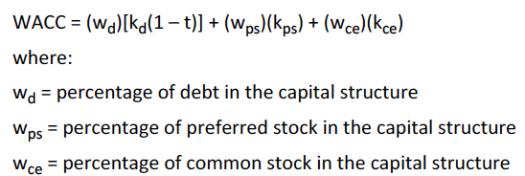

## Describe the use of target capital structure in estimating WACC and how target capital structure weights may be determined

The WACC should be calculated based of the firm’s target capital structure. Which is the market value of the capital components that the firm expects to achieve.

The current capital structure may also be used. Also, it can be taken as a base point and use past trends to change the capital structure. An industry average is also valid.

## Explain how the marginal cost of capital and the investment opportunity schedule are used to determine the optimal capital budget

Investment opportunity schedule: are simply the possible new investments arranged using the IRR.

Marginal cost of capital curve: Simply shows how as new capital is invested, the cost of capital increases.

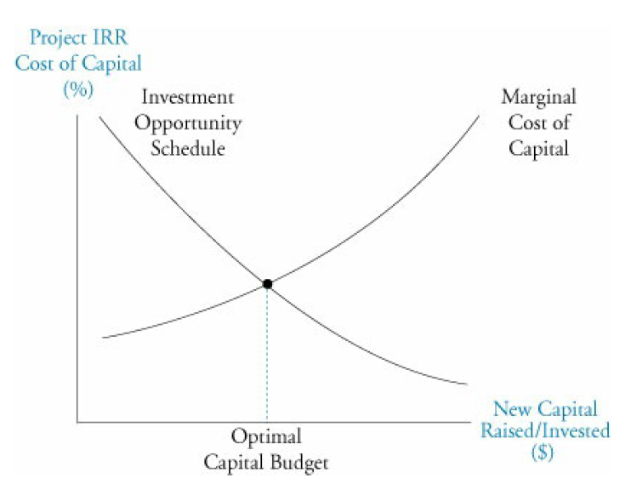

The optimal capital budget considers only projects in which the IRR is higher than the cost of capital.

## Explain the marginal cost of capital’s role in determining the net present value of a project

It is important to consider that the WACC is only appropriate for a project that has kind of the same risk as the one of the firm. This is why an adjustment to the discount rate must be done.

Leaving these issues aside, the WACC can be used to determine the NPV.

## Calculate and interpret the cost of debt capital using the yield-to-maturity approach and the debt-rating approach

If a company is not publicly traded, the analyst may use the company’s credit rating and the maturity of its debt in order to determine and approximate cost of debt using the yield curve for the specific debt rating. This is an example of matrix pricing.

When the company face a floating rate, the analyst should estimate longer-term costs of debt by using the appropriate yield curve (term structured).

## Calculate and interpret the cost of noncallable, nonconvertible preferred stock

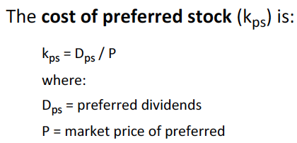

This is simply a re-arrangement of the formula of the dividend discount model.

## Calculate and interpret the cost of equity capital using capital asset pricing model approach, the dividend discount model approach and the bond-yield-plus risk-premium approach

The rationale ere is that the company could use retained earnings to buy back shares instead of issuing stocks to finance projects.

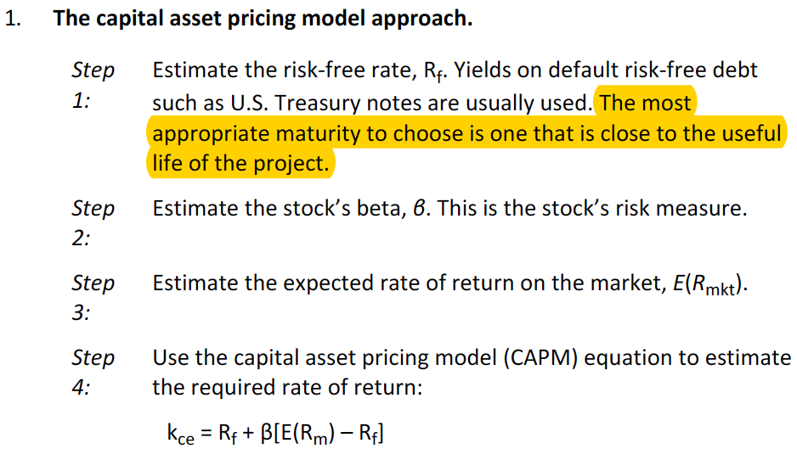



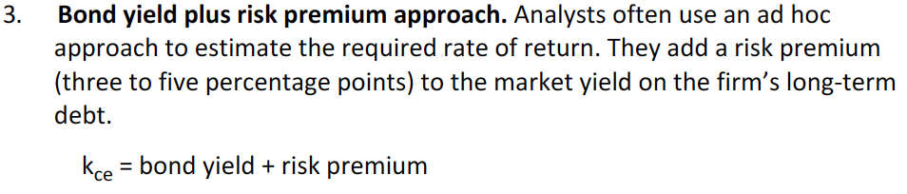

## Calculate and interpret the beta and cost of capital for a project

Beta -> systematic or market risk.

When estimating a project beta, different methods may be followed. The first one may be using a beta of a publicly traded firm which risks are similar to the ones of the project (known as the pure-play method). (For instances, the beta of a conglomerate would not be appropriate for a specific project that the company may be facing).

The grater a firm’s reliance on debt financing, the greater its beta. This is why for the past method, the beta of the publicly traded company must be unlevered and levered back with the financial structure of each company.

(The asset beta is the unlevered beta).

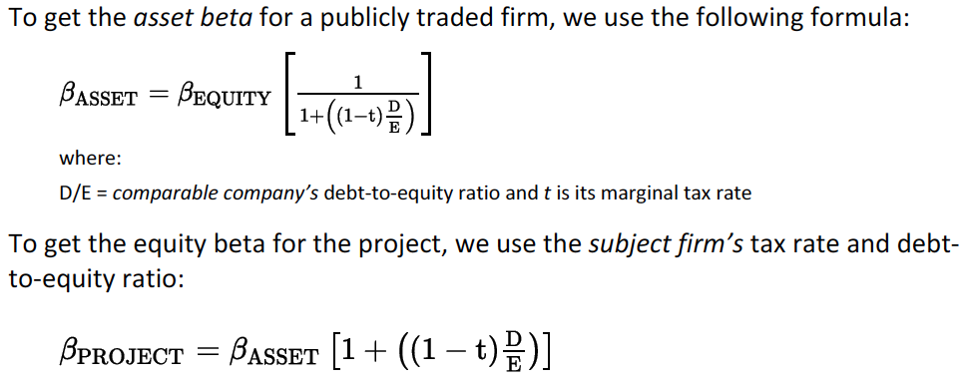

When I have the D/E ratio I can use the following formulas to find the proportion of each source of capital: D/(D+E) and E/(D+E).

Issues when calculating betas:

* Period of time used.
* Index used.
* Betas tend to revert towards one.
* Small-cap beta estimations may need an adjustment to display the risk.

## Describe uses of country risk premiums in estimating the cost of equity

The CAPM does not always reflect the country risk premium. The adjustment must be made by checking the sovereign yield spread (difference in yields of the country where the company can be found (which is denominated in local currency) and a treasury bond with a similar maturity).

To determine the country risk premium, the volatility of the markets should also be taken into account:

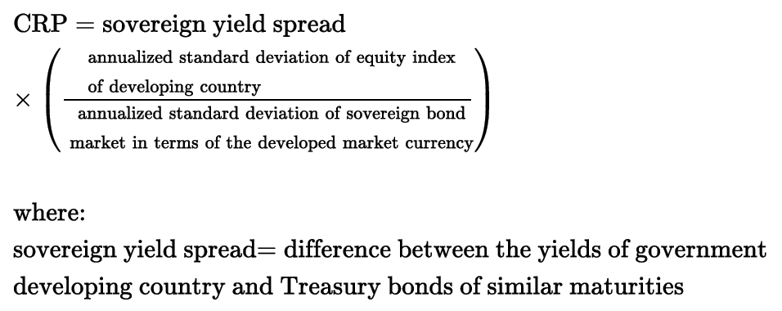

## Describe the marginal cost of capital schedule, explain why it may be upward-sloping with respect to additional capital and calculate and interpret its break-points

Marginal cost of capital is defined as the cost of the last dollar that firm may raise. It would be expected that this cost will be increasing since usually, if a company finance more and more its operations, it would need to offer riskier premiums to their creditors, which increases its cost of financing.

MCC schedule shows the WACC for different amounts of financing.

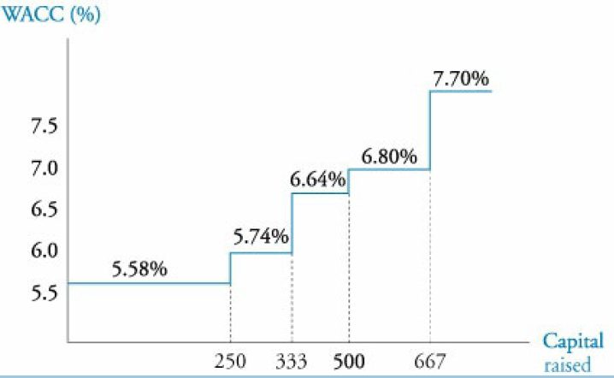

Break points occur when the cost of any source of capital changes:

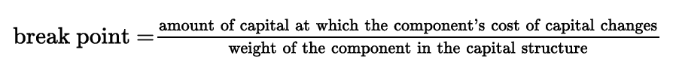

*Basicamente se hace esta division para saber cuanto seria el total de financiamiento considerando que tengo el valor de uno de los componentes.

To calculate it I must have a table in which it is explained when each of the components of capital may face a change.

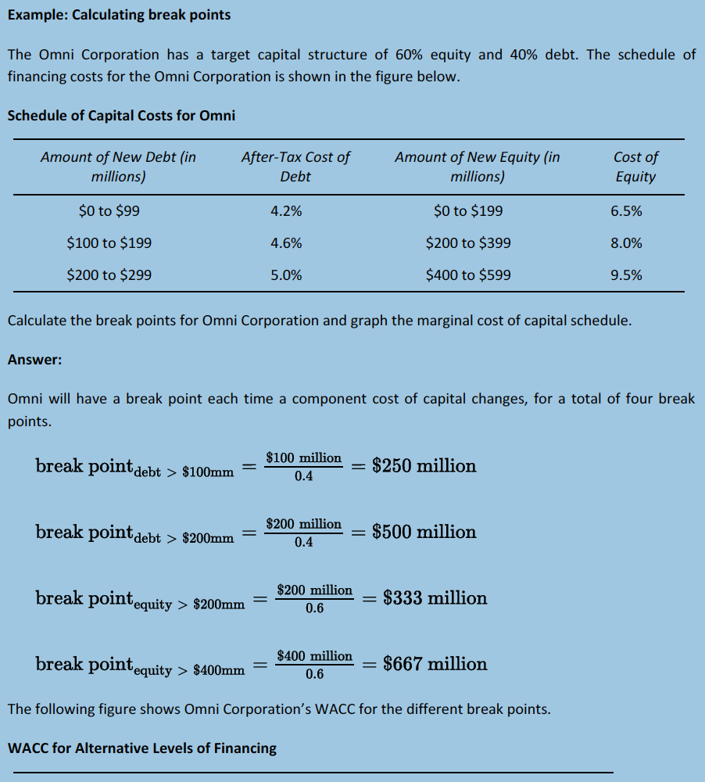

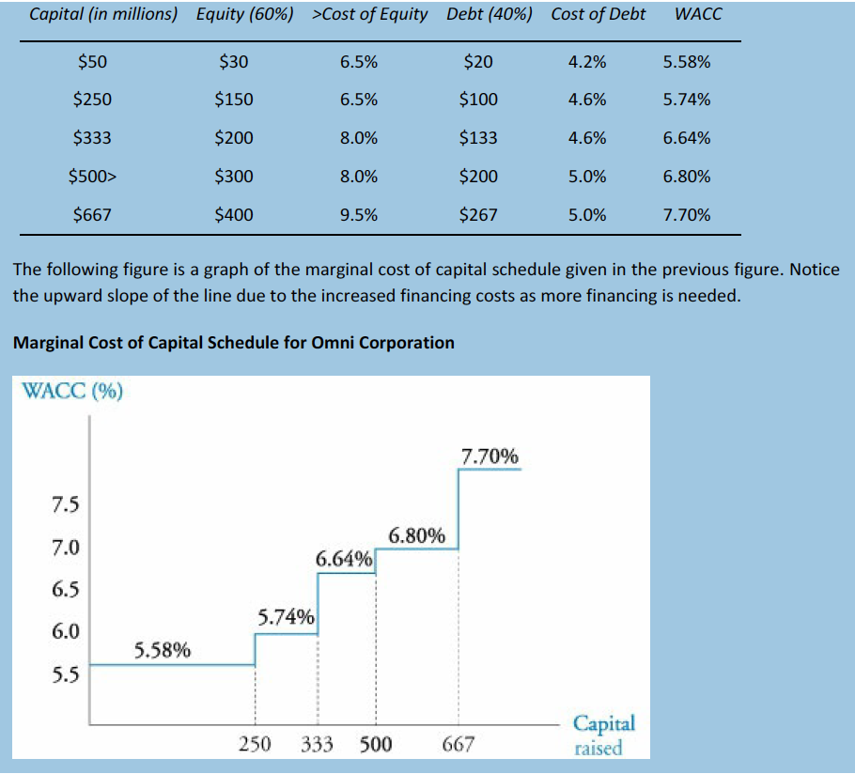

## Explain and demonstrate the correct treatment of flotation costs

Flotation costs are the fees charged by investment bankers when a company raises external equity (they normally go between 2% to 7%).

Since flotation costs are not an ongoing expense for the firm, they should not be considered as part of the WACC. So, they are simply considered as a part of the initial cash outlay. It is important to bear in mind that if the expense is tax-deductible, the after-tax value should be used.

# Reading 37: Measures of Leverage

## Define and explain leverage, business risk, sales risk, operating risk and financial risk and classify a risk

Leverage -> the amount of fixed costs a firm has, which includes some operating expenses and some financing costs. So, a change in sales leads to a greater change in operating earnings given a high operating leverage and, a change in operating earnings leads to a greater change in net income given a high financial leverage.

Business risk -> includes sales risk and operating risk.

Sales risk -> Uncertainty about the firm’s sales.

Operating risk -> Uncertainty about operating earnings caused by fixed operating costs. The greater the proportion of fixed costs to variable cost, the greater the risk.

Financial risk -> risk that the firm faces when its operations are financed with debt, due to the obligations that raise from any debt agreement. The greater the firm’s debt, the greater the risk.

## Calculate and interpret the degree of operating leverage, the degree of financial leverage and the degree of total leverage

Degree of operating leverage (DOL): percentage in EBIT that results from a change in sales:

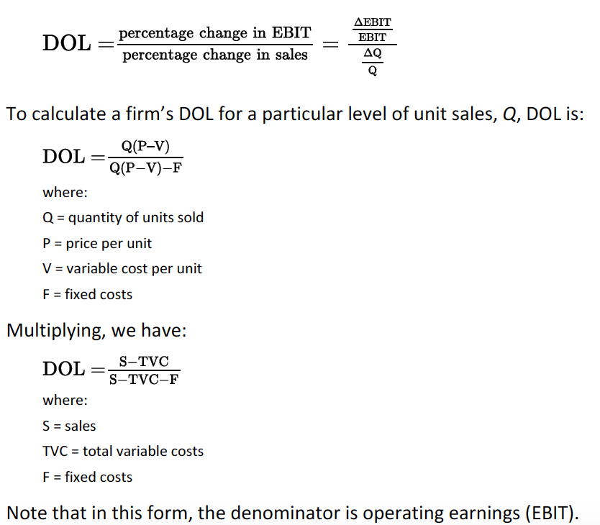

The DOL decreases as the level of sales increases. The result of the DOL can be simply be multiplied by the percentage change in sales to estimate the change in EBIT.

Degree of financial leverage (DFL): is the ratio of change in EPS to change in EBIT:

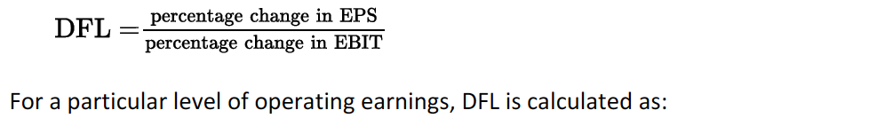



When any of these ratios equals to one, it means no leverage (no fixed costs or no interest cost).

Degree of total leverage (DTL): Measures the sensitivity of EPS to change in sales:

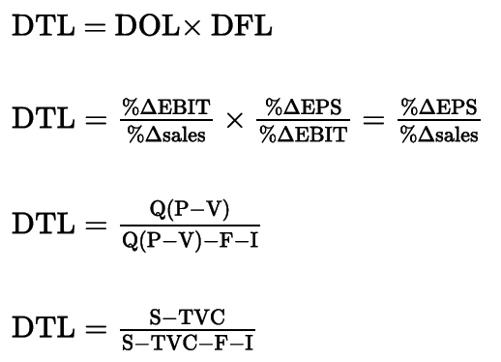

## Analyze the effect of financial leverage on a company’s net income and return on equity

Using financial leverage to finance a company’s operations will increase its ROE (although it reduces the net income, equity is way lower due to the fact that the source of financing has more debt included).

However, it is important to bear in mind that the ROE becomes more sensible when the company is levered.

## Calculate the breakeven quantity of sales and determine the company’s net income at various sales levels

## Calculate and interpret the operating breakeven quantity of sales

The breakeven point is the level of sales that allow the company just to cover all of its fixed and variable costs.

Contribution margin: difference between price and variable cost per unit. Is what is used to cover fixed costs.

Breakeven quantity of sales:

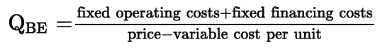

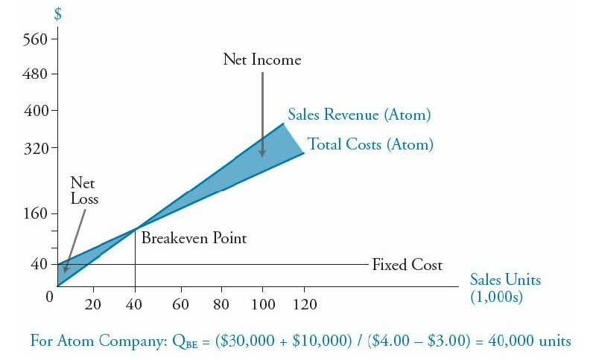

Although the degree of leverage is different for every level of sales, it is related to the slope of the net income line.

Why does the graph quantities and $ are not consistent?

Operating breakeven quantity of sales:

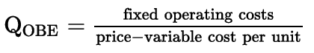

A firm that chooses a higher fixed costs structure, will face a higher breakeven point. The further a firm’s sales are from its breakeven point, the greater the magnifying effects of leverage on net income.

And the breakeven point in $?

# Reading 38: Working Capital Management

## Describe primary and secondary sources of liquidity and factors that influence a company’s liquidity position

Primary: cash used in day-to-day operations. Sales, receivables collection, short-term investments, short term funding and effective cash flow management.

Secondary: assets liquidation, debt agreements. Using this type of funding may actually change the company’s financial structure and operations significantly.

**Factors that influence a company’s liquidity position:**

* Cash flowing quicker into the company and leaving slower is consider as an improvement.
* Drags on liquidity: delays or reductions of cash inflows, as well as an increase in borrowing costs (includes uncollectable receivables, obsolete inventory and tight sort-term credit due).
* Pulls on liquidity: accelerated cash outflows. Paying vendors sooner for instance.

## Compare a company’s liquidity measures with those of peer companies

Current ratio:



Quick ratio or acid test: The difference is that here, inventories are not considered as assets that will later be available to pay current liabilities.

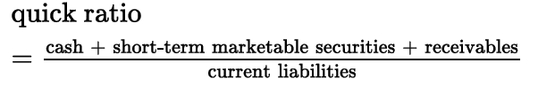

Receivables turnover: It is desirable to have a ratio close to the industry’s one.

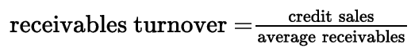

Number of days of receivables: Simply multiply the inverse of the past ratio by 365. Again, it is desirable that the number of days falls close to the industry’s norm. Also, the credit terms of the firm are a good reference point.

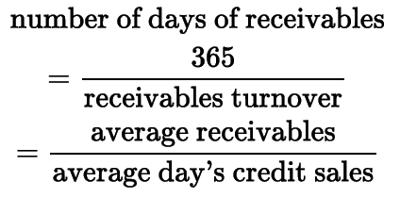

Inventory turnover: efficiency in processing and selling its inventory.

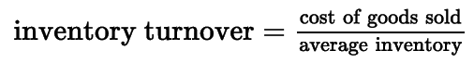

Number of days of inventory: A low number of days may suggest that sales are being affected due to stockouts.

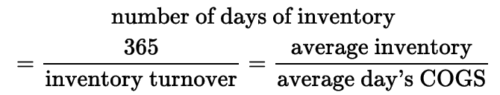

Payables turnover:



Number of days payables:

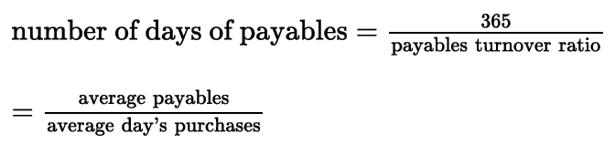

## Evaluate working capital effectiveness of a company based on its operating and cash conversion cycles and compare the company’s effectiveness with that of peer companies

Operating cycle: How much time does it takes for the company to convert raw materials into proceeds from sales.



Cash conversion cycle or net operating cycle: time that it takes the firm to convert its cash investment in inventory back to cash (in the form of collections of its proceeds from sold inventory).

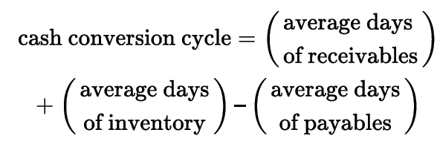

A high CCC means that the company has an excessive investment in working capital.

## Describe how different types of cash flows affect a company’s net daily cash position

Daily cash position: uninvested cash balances a firm has available to make routine payments. The firm should have enough but not excessive cash. Forecasts can be done by checking regular inflows and outflows that the company faces.

## Calculate and interpret comparable yields on various securities, compare portfolio returns against a standard benchmark, and evaluate a company’s short-term investment policy guidelines

Adjustable-rate preferred stock: are stocks that pay a dividend which is reset quarterly and, in some cases, generates a tax advantage.

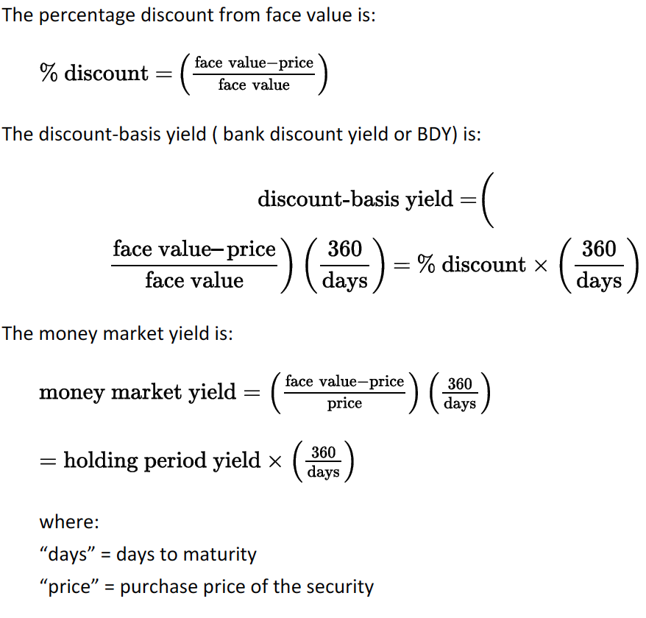

The bond equivalent yield:

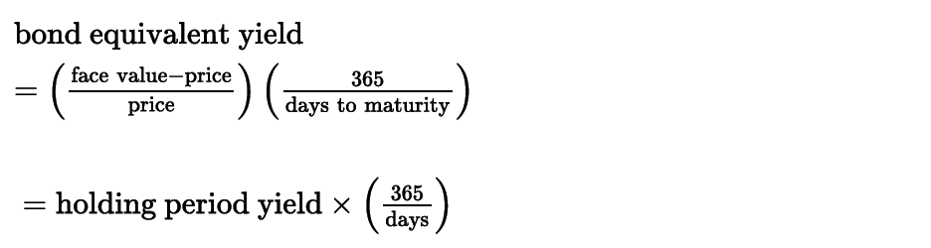

Check all these measures, specially the different names and compare them with the ones of quantitative methods.

The return of the firm’s short-term securities investments should be stated as bond equivalent yields while the ones on a portfolio as a weighted average of these yields.

**Cash management investment policy**

Short-term cash is usually invested in high credit quality and with short maturity securities.

An investment policy must be written in order to stablish the specific guidelines of how to invest.

## Evaluate a company’s management of account receivable, inventory and accounts payable over time and compared to peer companies

**Receivables management**

Aging schedule: Shows the status of the receivables. It can be presented in absolute and relative values.

Weighted average collection period: indicates the averages days outstanding per dollar of receivables. Simple multiply the average collection days of each “band” (the ones used in the aging schedule) by the weight of each band and sum them up.

**Inventory management**

Inventory management is an important component of the overall financial management and it should not be that high nor that low. It can affect sales and efficiency either way.

**Payables management**

It is important to have an adequate management of accounts payable: if the company pays to its suppliers after its due date, it may face high interest and negatively affect its relationships. On the other hand, paying it too early reduces its days of credit.

Companies may have special payment terms like 2/10 net 60, meaning that the company may have a 2% discount if it pays on the first 10 days but must pay the whole amount in its normal terms (60 days).

The cost of not taking the discount for early payment can be computed as:

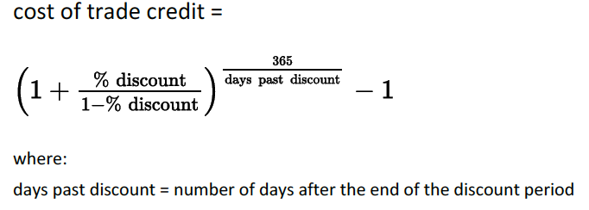

## Evaluate the choices of short-term funding available to a company and recommend a financing method

**From banks:**

* Uncommitted line of credit: a line that the bank may discontinue at any time in the case that circumstances change.
* Committed (regular) line of credit: a line that the bank must commit to offer for a certain period of time. This type of lines is also known as overdraft lines of credit. Are more reliable than the uncommitted ones. Committed lines of credit are normally for terms less than a year.
* Revolving line of credit: It is even more reliable as it may have longer terms (more than a year). As well as committed lines, this one can be verified in the company’s financial statements footnotes.

These loans may require certain assets as collaterals. Usually, for short-term loans, short-term assets are used and for long-term loans, long-term assets.

Blanket lien: gives a claim to a bank of all current and future firm assets as collateral in case the primary collateral is insufficient and the firm defaults.

Banker’s acceptances: is a guarantee from the bank that the importing company will deliver the goods. The exporting firm can then sell the acceptance at a discount to obtain its founds immediately.

Factoring: Sale of receivables at discount. The “factor” is the buyer of the receivables.

**Not from banks:**

There are institutions that offer financing to smaller and riskier companies (but at a higher cost).

Another option is to issue a short-term debt security known as commercial paper. Its interest cost is usually lower.